Load

**Lw**

This is the initialization of the memory segment.

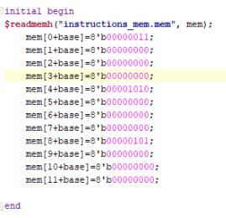

Lw x1, 0(x0)

Note that at cycle 5, the register x1 contains the value 3 that was in address zero in the memory

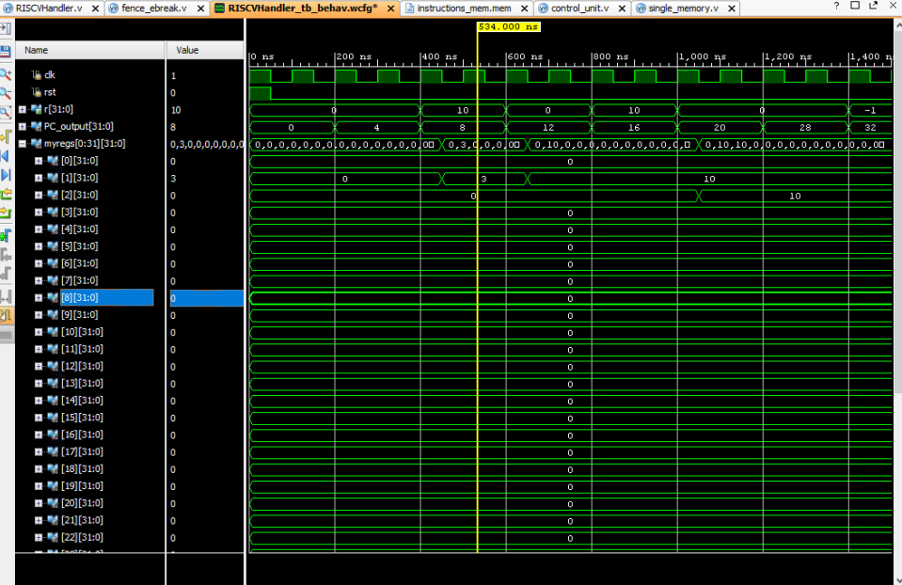

**Lh**

Lh x1, 0(x)

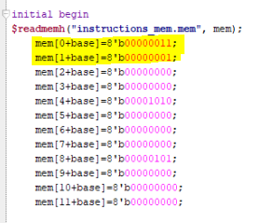

The first half byte contains the value 0000001100000001 which is equivalent to 259 in decimal which is the number stored in x1 which means load half is working properly

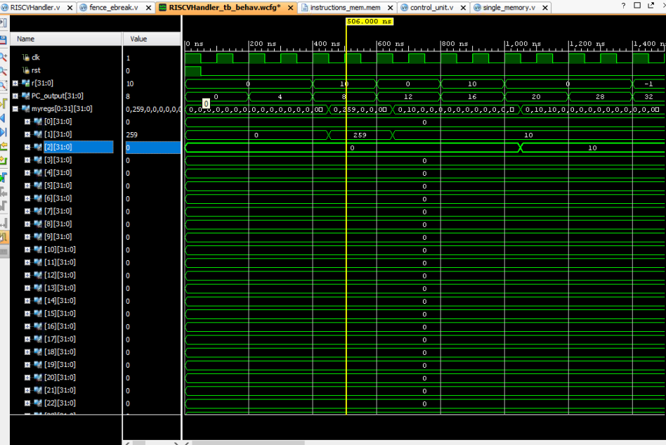

**LB**

Lb x1, 0(x0)

The memory block

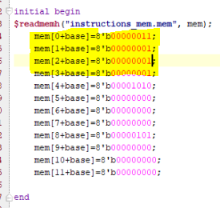

Note that I edited the every other byte after the first one to contain 1 in the least significant bit to assure that load byte works correctly, and when I load byte, it loads only the first byte as shown in the screenshot while not reading any other byte

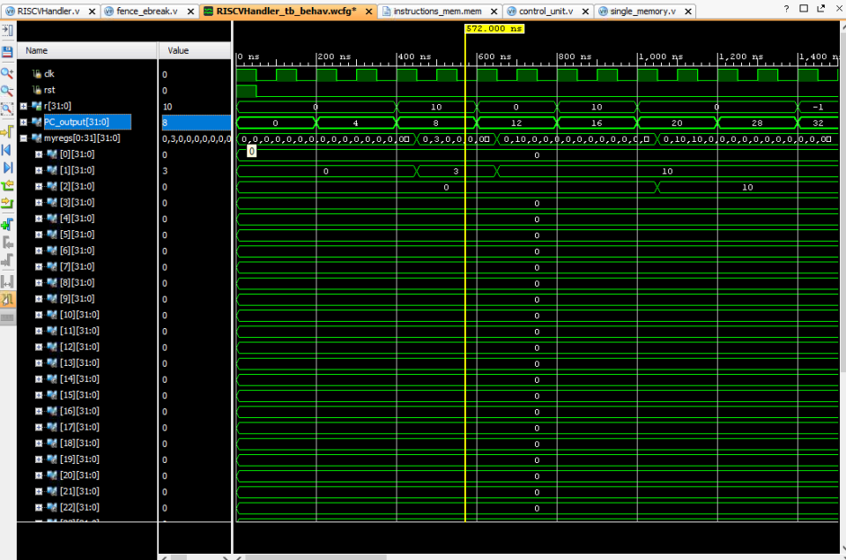

**LBU**

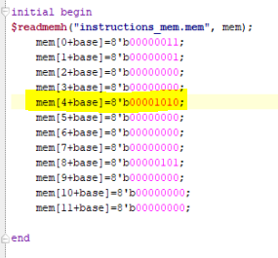

Testing code:

LBU x1, -4(x)

I loaded the fourth byte in unsigned mode, as shown in the screenshot register x1 contains the value 10 which resides in the fourth byte in the memory

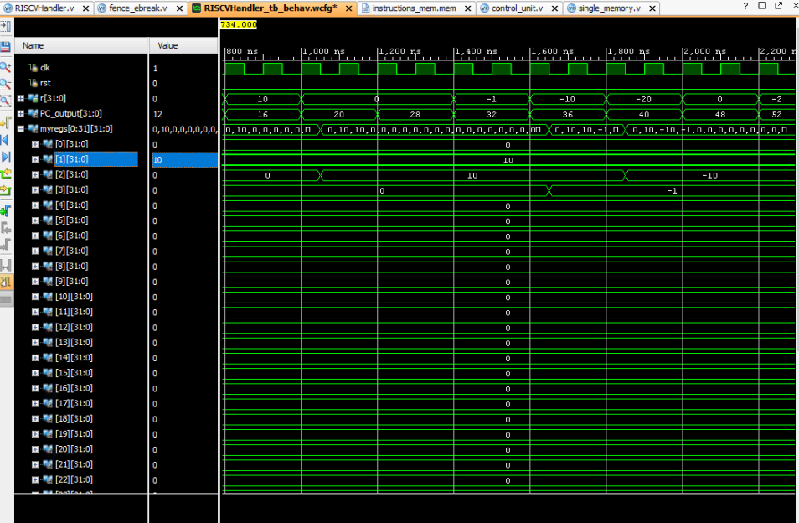

**LHU**

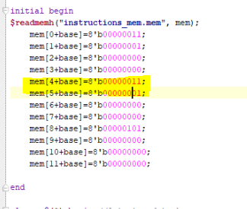

Testing code:

LHU x1, -4(x)

I loaded the fourth and fifth byte in unsigned mode, as shown in the screenshot register x1 contains the value 259 which is the value resides in the fourth byte in the memory

